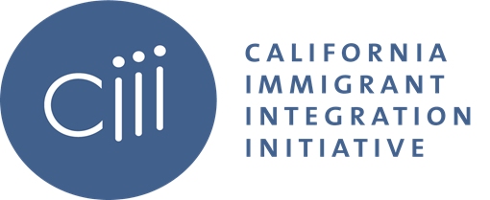

LSWG QI Meeting Agenda
Wednesday, March 23, 2022
10:30 am-12:00 pm PT

Welcome & Introductions
- Announcing Navin as LSWG Co-Chair!
- Registration is up for the 2022 GCIR Convening! To register click here.

Updates
- National Updates
- State Updates
  - 2022 Governor’s Budget: Health Care for Immigrants
    - By Sarah Dar, Director of Health and Public Benefits Policy, California Immigrant Policy Center (CIPC)

  - Announcement on Funder briefing to support Deportation Defense & Know Your Rights work

  - California Families for Dignity Fund
    - Overview: The California Dignity for Families Fund was set up as part of a public-private partnership with the State of California to address the urgent humanitarian needs of migrants at the southern California border, ensure due process for asylum seekers, and support their integration into receiving communities. In August 2021, we expanded the Fund’s purpose to include support for families and individuals from Afghanistan and Haiti arriving in California. This expansion of purpose is in recognition that what is happening at the southern border is deeply related to the experience and needs of Afghan and Haitian families.
    - Current Updates
      - The Adv Comm has just submitted a 3rd docket of recommended grants to Tides, totaling approx. $2.8mm. Now that all of the grantees have been notified, we'll be sharing more details about this docket with the Fund donors by early next week.
      - As grantmaking winds down, our focus is on learning dissemination and knowledge sharing. Of note,
        - We launched the learning series! For more information click here.
        - Our evaluator has just completed a first round of learning interviews with the Fund grantees (she spoke to 22 of the 23 current grantees, 96% response rate). We'll be sharing that learning sometime in April/May

  - Legal Services Funding (Luis Perez)

Addressing Issues in the Legal Services Pipeline Panel Discussion
- A recent study on immigration legal services in California recommended various ways in which funders could address the overwhelming need for representation and the lack of service providers. Among them was the need to support a pipeline of attorneys and other accredited representatives to serve immigrants. The Legal Services Working Group, a standing committee coordinated by Grantmakers Concerned with Immigrants and Refugees (GCIR), will host a panel for funders. The panel will ​highlight and discuss ​current models ​working to address​ the pipeline issue:
  - Christopher Punongbayan, Executive Director, California ChangeLawyers
  - Julissa Peña Executive Director, Santa Barbara Immigration Legal Defense Center
  - Dan Torres, Program Director, Immigrant Rights, Haas Jr. Fund
  - Kelsey Morales, Litigation Fellow, Immigration Unit Office of Alameda County Public Defender’s Office
Closing & Next Steps
- Next LSWG meeting will be on Wednesday, September 28 at 10:30 am.

