Follow up information for CA Census Funders

**Census Bureau Funding**

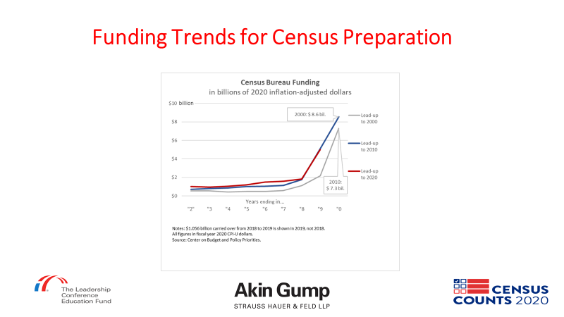

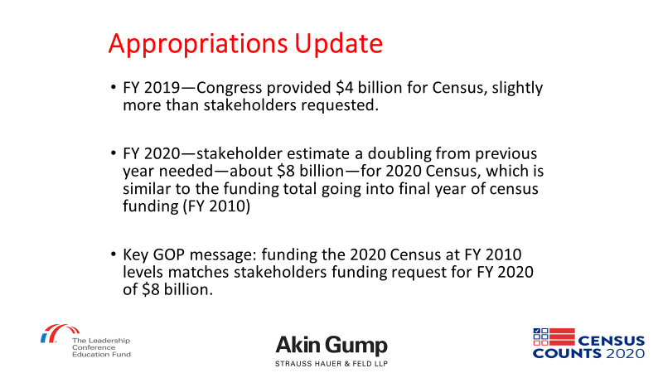

**Creation of Legal Defense Funds**

Reaching out to Bob Tracy at Minnesota Council on Foundations for more info

**Introducing “Noise” into Census Data**

<https://www.aaas.org/news/new-privacy-protections-highlight-value-science-behind-2020-census>

<https://digitalcommons.ilr.cornell.edu/ldi/49/>