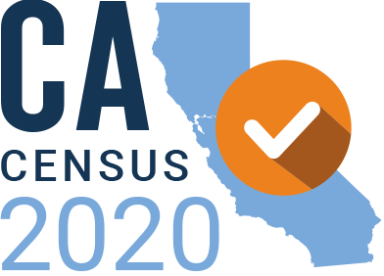

The California Census 2020 Statewide Funders’ Initiative was established in 2017 in order to achieve two overarching goals:
- To ensure that hard-to-count populations in California are accurately counted
- To build a stronger movement infrastructure across the state that can improve opportunities and conditions for Californians who have been politically, economically, and socially marginalized

Count All Kids
Recommendations for the Count of Young Children

In the 2010 Census, an estimated 2.2 million children were missed, with a net undercount of nearly 1 million (the net undercount is number by which the total count was lower than the actual number of children; it is calculated by subtracting double counted children from the omitted children), with young Latino and black children having the highest net undercount. (Data for Asian American children and other demographic groups is not available for the 2010 Census.) California had the second biggest net undercount in the country; the count for California was nearly 102,000 children less than it should have been. The undercount of young children has worsened since 1980. Children under 5 are undercounted at a higher rate than any other age group. California has a much larger population of young children than any other state. More than 1.5 million infants and toddlers live in California families, with 62 percent of them born into low-income households likely to rely on crucial support services that receive federal funding determined by the census.

Children are more likely to be missed in a census if:
- They live in large and complex households
- They live with single parents or young parents between the ages of 18-29.
- They are not the biological or adopted child of the householder.
- They live with their grandparents, aunts and uncles, or other family members
- Their family shares a household with another unrelated family
- Their family is living “temporarily” with another household and doesn’t have a permanent residence
- They live in families that do not speak English or their family includes immigrants.
- They live with poor families.
- Their families rent rather than own their home.
- Their family moved in the last year.
- They were born shortly before Census day.
- Finally, some adults may not realize that babies, toddlers and young children are supposed to be included in the Census. Census Bureau research shows that 4 out of 5 children missed in the 2010 Census were from households that returned their Census forms or were otherwise counted but left children off.

According to a recent analysis by Dr. Bill O’Hare, the nation’s leading expert on the child undercount, nationally, children 0-4 were undercounted in the 2010 Census by 4.6%, and young children aged 5-9 were undercounted by 2.2%. The age demographic with the third largest undercount was adults 30-34 years old, at .7 percent. (Young black men aged 18-39 were missed at a higher rate, as were young Hispanic men aged 18-29, but since those groups are smaller, fewer people were missed.)

Because young children are often missed in households that return the Census form, this means going beyond using the Hard to Count maps. Dr. Bill O’Hare and colleagues are working to develop a better approach to identifying these communities; in addition, child advocates are encouraging both the Census Bureau and the CUNY Hard to Count map project to add features to help find these kids. Sign up at countallkids.org to be notified when the tool is ready, in late spring.

Because young children are often missed in households that return the form, the Partnership for America’s Children is conducting message research focused on young children and will produce outreach materials such as posters and flyers that can be used to educate families about the need to include young children when they fill out the form. It is also producing webinars on counting young children and a fact sheet that will answer many questions about when and how young children should be counted, all of which can be useful for California community organizations.

Public and Private Investments

Current Private Funding: TBD

Current Young Children Funders: Blue Shield of California Foundation, California Community Foundation, Heising-Simons, LA Partnership for Early Childhood Investment, Packard Foundation, and First 5 LA

Current Grantees: Partnership for America’s Children, First 5 Association, and NALEO

Public Dollars: waiting to hear from the state for more updated information.

Part of the California Census Office’s outreach strategy is to engage K-12 students, teachers, and parents to provide information about the importance of the Census. The Census Office is utilizing the data from Title I schools and Title III students to target hard-to-reach students. Title I is a federal program for children who live in high concentrations of poverty and Title III is a program for English-language learners that serves mostly immigrant children.

Recommended Strategies for 2020 Census
- Education and Awareness Building
- Fund education and training for children serving organizations to leverage their connection with families and young children. Ensure that they have the information and tools to support the count of young children in the 2020 Census that are being developed by the Partnership for America’s Children and the Count All Kids Campaign. Examples: Health Community Clinics, Early Childhood programs, Preschool Programs, public schools.
- Fund a series of webinars educate CBOs on why it’s important to target outreach to families with young children.
- Look for opportunities to fund diverse media that can target different communities, with a focus on media that young parents and other families with young children use, including parenting blogs and newsletters.
- Leverage the First 5 Network across California. The First 5 Association is kicking off “Every Child Counted” convenings with the goals to develop regional 0-5 Census 2020 Outreach Plans in all six First 5 Regions across the state to ensure every child is counted in the 2020 Census.

- Message and Tool Development and Testing Focusing on Young Children
  - Produce or contribute to the production of education materials in multiple languages, including printing materials for CBOs to distribute
  - Support the dissemination of education and GOTC materials
  - If you fund focus groups in various languages, test different word choices for who lives in the household to see which is most inclusive

- Partnering with Regional Anchor Organizations and CBOs with Trusted Relationships in the Community
  - Identify trusted messengers with direct connection to families and young children

Tactics

- Create or contribute to a rapid response fund. Set aside additional funding that is highly-flexible and easily accessible to address low response rates during the census year, particularly from March through June.

The Baby Futures Fund will be offered as a vehicle by which other funders interested in this population can direct their grant dollars to support training for organizations working with families with young children as well as communications/messaging and outreach support to activate organizations in local GOTC efforts. Using the existing infrastructure of the Baby Futures Fund and borrowing from the example of the Investors Committee, the LA Partnership will operationalize a Census set-aside within the Fund and invite funders who either contribute directly to the Census fund or align their grantmaking to support projects supported by the Census fund to join a 0-8 committee where grant opportunities will be presented and reviewed for possible funding. The funding can be directed statewide. Contact Kaci Patterson (kaci@investinkidsla.org) for more information.
- Promote an accurate understanding of the young children undercount to funders and CBOs and how it’s different from other groups.
  - Produce op-eds, blog posts or mailings to your network and grantees about the importance of counting young children.
  - Organize webinars and host meetings for CBOs focused on the count of young children
  - Ensure that partners have access to targeted messaging specific to young children

- Continue to articulate the need especially to funders across California, some of whom have shown interest to in the gaps. If they are funding message research in languages, ask them to test different words for who lives in the household.

- Work with the local ACBO that was awarded the state contract to ensure there is a focus on young children. See attached for a list of ACBOs.

- Identify opportunities to partner with the State to address the undercount of young children. (TBD)

- Sign up at countallkids.org to be part of the campaign to Count All Kids. Receive updates on the latest research, webinar information and notification when outreach materials are available on the website.

Geographic Focus
- Fund key geographic areas that have large populations of young children that are likely to be missed (which may or may not be in HTC communities) but low resources.

Table 1: Estimated Net Undercount Rate for Young Children Age 0 – 4

Below is the list of large counties that had the highest net undercounts in 2010. Those highlights are currently receiving private funding. This list does not include all 58 counties in California.

National Rank | State Rank | County name | Total Population  (all ages) | DA Net Undercount  Age 0-4
12 | 1 | Santa Cruz County | 262,382 | -8.4
31 | 2 | San Diego County | 3,095,313 | -6.7
51 | 3 | Santa Barbara County | 423,895 | -5.9
65 | 4 | Orange County | 3,010,232 | -5.5
70 | 5 | Los Angeles County | 9,818,605 | -5.4
86 | 6 | Ventura County | 823,318 | -4.9
98 | 7 | Monterey County | 415,057 | -4.5
113 | 8 | Santa Clara County | 1,781,642 | -4.1
127 | 9 | San Francisco County | 805,235 | -3.9
132 | 10 | Placer County | 348,432 | -3.8
153 | 11 | Alameda County | 1,510,271 | -3.3
158 | 12 | Riverside County | 2,189,641 | -3.2
174 | 13 | Fresno County | 930,450 | -2.8
180 | 14 | Solano County | 413,344 | -2.7
184 | 15 | Sacramento County | 1,418,788 | -2.6
185 | 16 | San Joaquin County | 685,306 | -2.5
198 | 17 | San Bernardino County | 2,035,210 | -2.2
199 | 18 | Stanislaus County | 514,453 | -2.2
201 | 19 | Contra Costa County | 1,049,025 | -2.2
202 | 20 | San Luis Obispo County | 269,637 | -2.2
237 | 21 | Kern County | 839,631 | -1.1
241 | 22 | San Mateo County | 718,451 | -0.8
245 | 23 | Tulare County | 442,179 | -0.6

Note: The Subnational Demographic Analysis (DA) estimates were used to estimate net coverage error for young children in the 2010 Census. These data were produced in March 2018 and were not part of the official 2010 Demographic Analysis estimates. The Subnational DA series was released to inform interested parties of research and to encourage discussion. Source: U.S Census Bureau, Subnational Demographic Analysis estimates, special tabulation.

Funding Map
The map reflects all foundation grants dedicated to children ages 0-9 by county as of October 2018. Not included is a grant from Blue Shield of California Foundation, which would bring the total dedicated funding to $965,000. The Packard Grant is also not included in this total. Again, Imperial county, with a high percentage of children by county, lacks funding, as well as San Bernardino, Riverside, and Yuba counties.
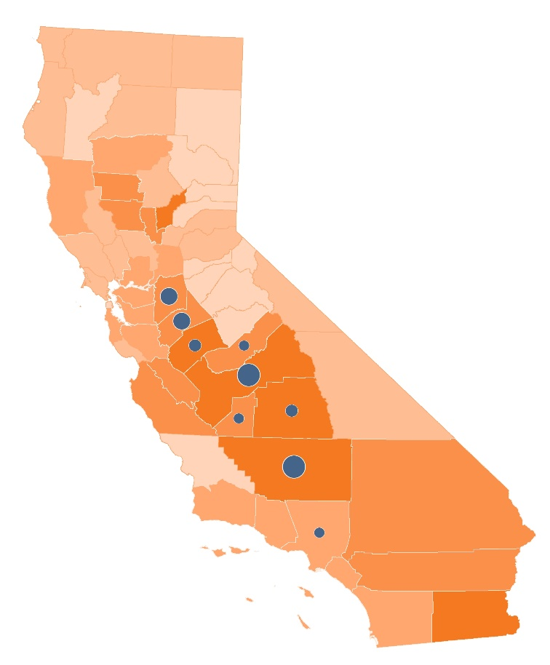

Counties receiving funding: Los Angeles County, San Joaquin County, Stanislaus County, Merced County, Madera County, Fresno County, San Luis Obispo, County Tulare County, Kern County and Ventura County

