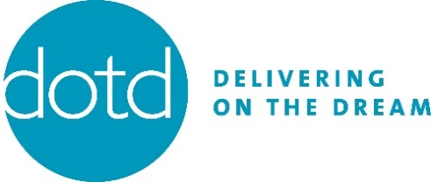

DOTD Grantee Final Report Form 2020-2021

Education/Outreach
1. What is the total number community outreach and education events you held? (inclusive of virtual events) Best estimates are acceptable and while a breakdown between in-person and virtual is welcome when available, it is not necessary.

2. Do you have any other key observations and/or lessons from the education and outreach you provided?

Legal Services
3. Please list the total number of individuals for whom legal service assistance was provided to. Best estimates are acceptable and while a breakdown between in-person and virtual is welcome when available, it is not necessary.

4. Please list the type of applications filed for relief. (You can check more than one box.)
DACA
Family-Based Petition
Fraud-Prevention
Legal Permanent Residence
Special Immigrant Visa
T-Visa
TPS
U-Visa
VAWA
Deportation Defense
Naturalization
Asylum

5. Do you have any other key observations and/or lessons from the legal services you provided?

Capacity Building
6. How many of your staff were able to participate in leadership, management, and/or relevant subject-matter trainings/conferences?

7. Describe what investments you made this year to strengthen your capacity (Example: buying digital equipment and licenses for staff, securing accreditation/recognition, upgrading program facilities, etc.)

8. How, if at all, has your staffing and volunteer capacity changed?

Advocacy/Organizing
9. What are the issues that your organization engaged in advocacy on? (Example: DACA, Public Charge, 287(g), Driver's Licenses, etc...)

10. What were the major strategies and activities you used? (Example: community organizing meetings, media engagement, legislative meetings, rallies, marches, etc...) If you worked on a campaign, what role did you play?

11. What were the key challenges and successes of your advocacy efforts?

Leadership
12. Describe how you supported leadership development and centered immigrant voices in your work.

13. Describe how you supported power building in immigrant communities, including intersectional efforts.

Short-Answers
14. How did the COVID-19 pandemic impact your work this year? How did you navigate your work internally and externally?

15. If you included mental health support for community members as part of your work through DOTD, please describe here.

16. What are 1-2 key lessons learned and/or promising practices that emerged during the reporting period (no need to repeat any lessons reported earlier in this form)?

17. What are the key challenges you encountered during this reporting period (beyond COVID-19; also no need to repeat any challenges mentioned earlier in form)?

18. Describe any new partnerships and how they strengthened your work.

19. Please share a meaningful anecdote on the human impact of your programs/activities.

