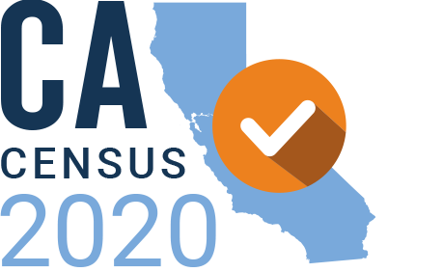

**Census 2020 Regional Updates**

**Updated 03.21.19**

**Inland Empire**

* The Inland Empire Census Funders Table is established to drive toward a collaborative fundraising goal of **$1 million** from private philanthropy that will be granted to nonprofit organizations working to achieve a complete count on the 2020 Census.
* The Community Foundation will house the pooled fund and will serve as the region’s ACBO, with the goal of close coordination of distribution of funds for Census.
* As of 3/21/19, there is **$255,000 secured** for the pooled fund.

**Los Angeles County**

The California Community Foundation (CCF) has been named L**A region’s Administrative Community-Based Organization *(*ACBO*).***

CCF funded the **Los Angeles Regional Census Table (LARCT)**, which provides a space for organizations engaged in advocacy, field research and community engagement to coordinate 2020 Census outreach efforts in partnership with County and City governments. LARCT developed a regional plan to engage community groups in outreach activities and strategies to support for CCF.  As of January 2019, LARCT was expanded to ensure full representation and accessibility of nonprofits from across Los Angeles County. LARCT is now comprised of six organizations:

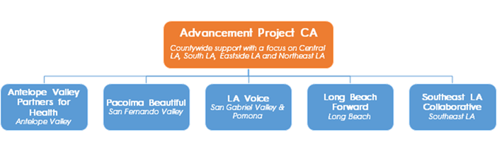

CCF has learned a lot from these groups, and they have shaped our Census planning. Through these regional convenings, we will continue to listen to the needs of the community to effectively implement the set outreach strategies, which will also inform the upcoming countywide Request for Proposals that will be released in the next two months. LARCT will also assist CCF in getting the word out to their local organizations about funding opportunities.

The LARCT expressed the need for an umbrella communications campaign that will allow them to anchor Census participation as a major civic engagement effort in the region. An integrated approach fosters efficiencies through coordinating and leveraging resources between the grantees, LA County, LA City, state and federal stakeholders and other key partners. CCF is working the development and execution of an **integrated communications campaign strategy**. The elements of a campaign include unified messaging, tools and training for grantees, media relations, strategic media partnerships and evaluation. An analysis of the nearly dozen audience research is already underway for the messaging.

**Northern California**

* There are 3 pooled funds for the region – one fund for the 9-county Bay Area, one fund for Alameda and Contra Costa counties, and one fund for San Mateo and Santa Clara counties.  These funds will be distributed through the common RFP process discussed below.
* The Bay Are Census Funders Collaborative will release its RFP and open the application process for grants to support Census education, outreach, and organizing in the 9-county Bay Area on April 15, 2019.   The Collaborative, in partnership with the Region 3 ACBO and Census Bureau, will hold at least 5 information sessions across the Bay Area (San Francisco, Oakland, Marin, San Jose, and Redwood City) for potential applicants.  Applications are due on May 31.
* The Collaborative will work closely with the Region 3 ACBO and counties to ensure that funding is aligned and not duplicative across the region.

|  |  |  |  |
| --- | --- | --- | --- |
|  | **Bay Area Regional Pooled Fund** | **East Bay Pooled Fund** | **Peninsula & South Bay Pooled Fund** |
| **Pooled Fund Holder** | Silicon Valley Community Foundation | East Bay Community Foundation | Silicon Valley Community Foundation |
| **Fund Point of Contact** | Anne Im  aim@siliconvalleycf.org | Amy Fitzgerald afitzgerald@ebcf.org | Anne Im  aim@siliconvalleycf.org |

**Orange County**

* Charitable Ventures of Orange County has been named Regional ACBO, bringing $1.4M to our region
* We are working alongside our County CEO team to ensure aligned efforts, and have made philanthropy and nonprofit rep recommendations for the CCC roster
* We are putting in place a pooled Census fund comprised of private philanthropy, and starting in April, will be promoting ways to support the Census to OC Grantmakers members

**Ventura County**

* Over 150 Community Based Organizations, Faith-Based Organizations, Local Government, and Diverse Leaders in Ventura County have formed a local 2020 Complete Count Committee
* Ventura County Community Foundation was named ACBO by the State of California for Region 5
* Fundraising efforts to raise a minimum of $2.5 million for outreach and communications in HTC areas is underway

**San Diego**

* The United Way of San Diego was awarded the ACBO contract for San Diego and Imperial Counties and will be working with a coalition of over 100 CBOs.
* Jurisdictional funding will be managed by the San Diego Regional Association of Governments (SANDAG) and at a recent gathering about a dozen of the 18 cities in the region, plus a representative from the County of San Diego and several state representatives (elected officials and Census) gathered with CBOs in the room to begin planning government strategies and coordination
* San Diego Grantmakers announced that Debbie McKeon will join the organization as its President and CEO on April 8. Debbie comes from the Michigan Council on Foundations and is keenly interested in Census matters, looking forward to working with the California coalition

**Sacramento Region**

* ***In-Kind Support****:* Sacramento County sits within Region 1 and is among the Top 10 Hard to Count counties in the State.  Since June 2018, numerous organizations and community leaders have offered in-kind and, in some cases, cash support to be ready for the 2020 Census.  The Sacramento Region Community Foundation has injected over tens of thousands of dollars to prepare for Census 2020 and to launch Sacramento’s Complete Count Committee.  Sacramento County has allocated in-kind staff support for Census activities.  Notably, the 15 Community Steering Committee Members (Executive Directors or Director-level staff) have organized over 100 community groups to collaborate on outreach strategies, totaling nearly 1,000 hours of in-kind support for Census outreach since last October.  The community has demonstrated its commitment to achieving a complete Census count in 2020 and to ensure that ALL of our community members are counted but will need additional resources to achieve this goal.
* ***Expansive and Remote Region****:*Region 1 is incredibly expansive with many areas that are remote and the Federal Census outreach plans inadequately respond to the unique needs of the 17-county Region 1.  Parts of the region were also recently hit by last year’s wildfires.  A community-driven approach is essential for a Complete Count; thus, Federal and State Census outreach efforts MUST be supplemented with local experts and trusted messengers who have established long-standing relationships with hard-to-count populations and those least likely to respond. Additionally, the ACBO is partnering with a Consortium of Funding Partners and Regional CBOs to ensure a complete count.
* ***Power and Movement-building:***An advocacy committee, based in Sacramento County, is working to create solutions toward 2020 Census barriers.  Advocates and trained community organizers have been meeting to discuss ways to shift policy and resources in order to meet Region 1 Census goals.  The subcommittee is also reaching across statewide networks to ally with partners like CPAN and other immigrant/refugee-serving coalitions.  Most importantly, the Region is designing resource allocation and strategy to support civic engagement and power building capacity for 2020 Census and beyond.

**San Joaquin Valley**

* SJV have raised $885,000 to date from a total of 7 funders.  We expect another $350k total from 3 additional funders.
* Recognizing the importance of census to power building and civic participation, as well as to the allocation of public dollars related to dozens of government programs, in 2018, The Center, through the SJVHF, supported research to document the barriers and challenges to a complete count of HTC across the Valley. The SJV census research is significant in several ways:
  + It provided the nonprofit sector and HTC communities opportunities (through, e.g.,the one –on-one research interviews, focus groups, census research advisory committee, and learning opportunities) to actively engage in census discussions early.
  + The first three published [SJV census research reports](https://www.shfcenter.org/San-Joaquin-Valley-Census-Research-Project) serve as the basis for an amicus brief to be filed April 1 by National Immigration Law Center in the US Supreme Court in opposition to the proposed citizenship question on the census
  + The SJV research results informed and validated the “hands on/grassroots” outreach strategy proposed in the successful ACBO Region 4 and Region 6 applications. (The Center at Sierra Health Foundation was awarded the Region 6 contract; our IVE partners were awarded the Region 4 contract)
  + The SJV census research findings and their implications will serve as the grounding for the discussion The Center and several key SJVHF partners will hold with leg. staff from SJV state and federal legislative offices on April 4 regarding what state and federal officials can do to address the barriers and challenges to a complete count of HTC communities.