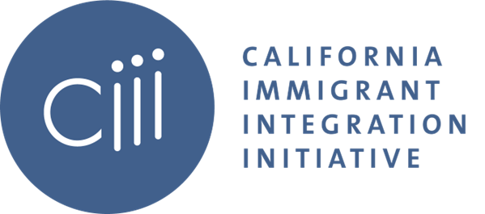

LSWG QIV Meeting
Wednesday, December 14, 2022
10:30 am – 12:00 pm PDT

Agenda:

- Welcome + Review Agenda

- National Asylum Rule Presentation

  - Eleanor Acer, Human Rights First

- Breakout Discussion

- Artistic Performance

  - Irma Herrera, Writer & Comedian

- Closing

