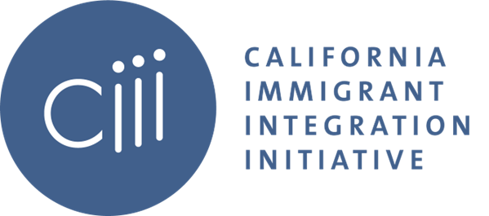

LSWG Q2 Meeting
Wednesday, May 17 2023
10:30 am – 12:00 pm PDT

Agenda

- Welcome

- DACA State of Play

  - Dan Berger, Curran, Berger, & Kludt
  - Katharine Gin, Immigrants Rising
  - Krsna Avila, Immigrant Legal Resource Center
  - Ju Hong, Dream Resource Center, UCLA

- Q&A/Group Discussion

- Closing

