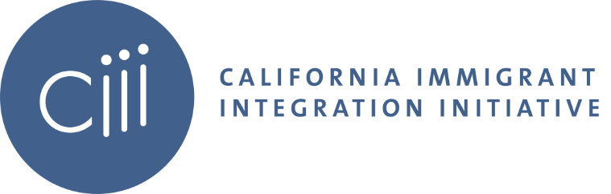
California Immigrant Integration Initiative (CIII) Quarter III Meeting Agenda
July 28, 2020 10:00 am – 11:30 pm PT
Facilitator(s): Cathleen Otero & Tessa Callejo

- Welcome (10:00-10:10 am)

- GCIR Leadership Transition Update (10:10-10:30 am)
      - Leadership Transition and Timeline Status
      - Presidential Search
      - CIII & Broader GCIR-affiliated learning communities
      - Co-Chair remarks
      - Questions

- GCIR Areas of Focus (10:30-10:42 am)
  - CA Updates
  - Legal Services Working Group

- CA Policy Update (10:42-11:02 am)
  - Gina Da Silva, Governor’s Office
    - Update on the State Budget and Response to the Joint Philanthropy Letter on Immigration
    - State Relief Fund
    - CA Values Act
    - Q&A

---------Break-----------
  - Cynthia Buiza, CIPC (11:07-11:27 am)
    - Detention/Deportation Update
    - Order to clear detention centers due to COVID-19 outbreak
    - State Budget Outcomes
    - Q&A

- Closing (11:27-11:30 am)

