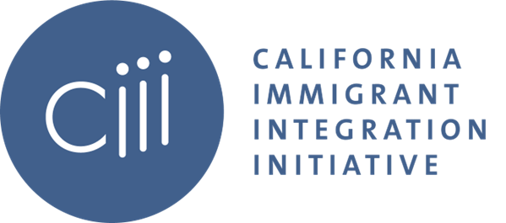

CIII QIV Meeting
Wednesday, December 07, 2022
1:30-3:00pm

- Welcome + Pair Offs
  - Name, Pronouns, Affiliation
  - What are your highlights from this year?

- National Policy Updates
  - Kerri Talbot, The Immigration Hub

- CIII & CA CEO Table Coordination

- Immigrant Integration Funders Convening Report Back

- Break Out Session

- Closing

