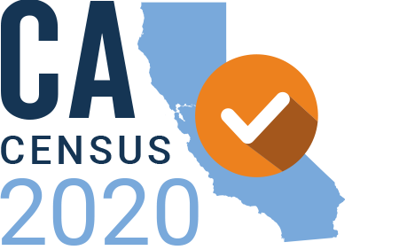
AGENDA

California Census 2020 Statewide Funders’ Initiative - Q2 Meeting
Tuesday, June 30, 2020 | 11am – 12:30pm
RingCentral Video Conference: https://meetings.ringcentral.com/j/1498687505

11:00am-11:05am | Welcome and overview – Christian Arana, Latino Community Foundation
11:05am-11:15am | Key national updates – Sheila Chung Hagen, GCIR 2020 Census Consultant
11:15am-12:00pm | Regional reflections and strategies, Q&A – Facilitator: Christian Arana, Latino Community Foundation  Presenters:  - Young children – Kaci Patterson, LA Partnership for Early Childhood Investment  - SF Bay Area (Region 3) – Stephanie B. Kim, United Way Bay Area  - Central Coast (Region 5) – Stephanie Bertsch-Merbach, Ventura Community Foundation  - Southern San Joaquin Valley (Region 6) – Cindy Quezada, Sierra Health Foundation  - Inland Empire – (Region 7) Sky Allen, Inland Empowerment  - Orange– (Region 9) Sarah Middleton, OC Census Fund  - San Diego/Imperial (Region 10) – Michele Silverton, United Way of San Diego  - Los Angeles – (Region 8) Stephania Ramirez, California Community Foundation
12:00pm-12:25pm | State census office analysis and plans, Q&A – Facilitator: Tara Westman, The California Endowment, Speakers: Ditas Katague, Director of the California Complete Count – Census 2020 Office, and Emilio Vaca, Deputy Director of Outreach, California Complete Count
12:25pm-12:30pm | Closing reflections – Facilitator: Tara Westman, The California Endowment

Background materials:
- CA Census Office Contracted Partner Survey Summary April 28, 2020 (attached)
- Adaptive Strategies to Get Out the Count: How California Census Grantees are Pivoting During the COVID-19 Pandemic

